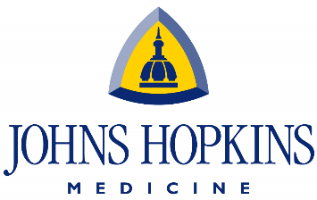
Pediatric Critical Care Medicine Fellowship
Department of Anesthesiology and Critical Care Medicine
The Johns Hopkins Medical Institutions
Charlotte R. Bloomberg Children’s Center
1800 Orleans Street
Baltimore, MD 21287
SCHOOL OF MEDICINE

12 Annual Sadie Abel Pediatric Critical Care Medicine Bootcamp
Friday, May 19 – Sunday, May 21, 2023

FACULTY PRE-REGISTRATION FORM

Please complete the pre-registration form - type or print clearly

Return the completed Faculty Pre-Registration Form to Sherrie Fornoff, sfornoff@Jhmi.edu

FACULTY PARTICIPANTS

Faculty will be provided instructional materials, food and beverage. There will be a faculty dinner on Friday, May 19, 2023.

Provide the name, email address, and for each faculty who will be attending the Bootcamp.

NAME OF INSTITUTION: _______________________________________________________________________________________
 | Last Name | First Name | Email Address
1
2
3
4
5

